PENETRATION TESTING REPORT
FOOTPRINTING, RECONNAISSANCE & NETWORK SCANNING
W2-PM-FINAL | CYBERSECURITY | NETWORKWALKS

Pentester Name | Aryan Doshi
Program / Batch | B082 – Networkwalks
Date | August 2026
Modules Covered | W2-PM1 – Multiple Kali Tools  W2-PM5 – Zenmap Scanning
Authorized Scope | Networkwalks (written permission) and own local LAN
Phases Covered | Phase 1 – Reconnaissance & Footprinting  Phase 2 – Scanning & Network Discovery

Cybersecurity Internship | Week 02

1. Executive Summary
This report documents the Week 2 practical cybersecurity activities completed as part of the Networkwalks internship program. The work covered two complementary areas: domain footprinting and reconnaissance using Kali Linux, and network discovery using Zenmap on the authorized local network. Together, these exercises demonstrate how a security professional moves from collecting publicly available information to identifying active systems within a controlled network.
The footprinting activity used WHOIS, WhatWeb, Nslookup, Curl, Wafw00f and DNSRecon against networkwalks.com within the stated authorized scope. The scanning activity used Windows IP configuration information and Zenmap Ping Scan to identify live hosts and build a network topology. The source report states that no exploitation or vulnerability validation was performed.

2. Authorization & Liability Disclaimer
All activities documented in this report were performed only against systems for which authorization was stated as secured, or against the author's own local network. The activities are intended for education and research. Reconnaissance and scanning must remain within the authorized scope.
Important: The observations in this report are not confirmed vulnerabilities. Identifying a software version, IP address, DNS record, HTTP header or WAF technology does not by itself establish a security flaw.

3. Scope and Objectives
- Collect publicly available domain registration information.
- Identify web technologies exposed by the target website.
- Resolve the domain name to its IP address.
- Inspect HTTP response headers.
- Identify the presence of a Web Application Firewall.
- Enumerate relevant DNS records.
- Identify the local LAN subnet and active hosts.
- Collect IP and MAC address information where available.
- Generate and preserve a network topology as evidence.
- Document security observations, impact and recommendations.

4. Tools Used
Tool | Purpose
Kali Linux | Primary operating system used for footprinting and reconnaissance.
WHOIS | Collect domain registration details, dates and name-server information.
WhatWeb | Fingerprint web technologies, CMS and exposed components.
Nslookup | Resolve a domain name to its IP address using DNS.
Curl -I | Inspect HTTP response headers and exposed application information.
Wafw00f | Identify whether a Web Application Firewall is present.
DNSRecon | Enumerate DNS records including NS, MX, SPF/TXT and service records.
Zenmap / Nmap GUI | Discover live hosts and collect network information.
Windows CMD | Identify local IP address, subnet and MAC information.

5. Phase 1 – Footprinting & Reconnaissance
The first practical activity focused on gathering information about networkwalks.com using multiple Kali Linux tools. Each tool provided a different perspective on the target's publicly observable infrastructure.

5.1 WHOIS
WHOIS was used to retrieve publicly available domain registration information and identify domain name-server information. The source evidence includes the WHOIS terminal output.

5.2 WhatWeb
WhatWeb was used to fingerprint the website. The reported results identified WordPress 7.0.4 and WP Download Manager 3.3.58, along with additional technology information.

5.3 Nslookup
Nslookup was used to resolve the domain name. The source report records the resolved IP address as 192.232.216.135.

5.4 Curl
Curl with the -I option was used to inspect HTTP response headers. The activity exposed additional web-application information, including the /wp-json/ WordPress REST API endpoint.

5.5 Wafw00f
Wafw00f was used to determine whether a Web Application Firewall was protecting the website. The reported result identified ModSecurity (SpiderLabs).

5.6 DNSRecon
DNSRecon was used to enumerate DNS information, including name servers, mail servers, SPF/TXT records, service records and DNS software information.

6. Phase 2 – Network Scanning with Zenmap
The second practical activity focused on network discovery within the authorized local network. The process began with the Windows ipconfig command to identify the local IP address and subnet. The subnet was then entered into Zenmap and a Ping Scan was used to identify active hosts.
The source report records the following example live hosts:
- 10.0.0.1
- 10.0.0.4
- 10.0.0.19
- 10.0.0.5
The source report notes that the practical example also contained four MAC addresses. It further records that the Zenmap Topology section was used to generate a visual network topology and that the topology was saved in PDF format.
Submission note: The source document explicitly states that the example subnet, host count and addresses should be replaced with the author's actual network results before final submission.

7. Findings & Risk Analysis
# | Finding / Observation | Potential Impact | Risk
1 | Web technology information exposed – WordPress and WP Download Manager identified. | May help attackers identify software requiring further security review. | Medium
2 | Server IP address identifiable – 192.232.216.135 recorded by Nslookup. | Provides information about the network location of the web service. | Low
3 | HTTP technical information exposed – response headers and /wp-json/ observed. | May assist technology fingerprinting and further enumeration. | Low
4 | WAF technology identifiable – ModSecurity (SpiderLabs) identified. | Reveals information about the web application's security architecture. | Low
5 | DNS infrastructure information exposed. | Can help build a broader infrastructure profile. | Medium
6 | Multiple live hosts visible on the local network. | Unexpected or unauthorized devices may potentially be present. | Medium
Risk levels above are observations from footprinting and scanning, not confirmed vulnerabilities. The practical exercises focused on information gathering and host discovery; no exploitation or vulnerability validation was performed.

8. Recommendations
- Review publicly exposed information about web technologies, CMS platforms and plugins.
- Keep CMS platforms, plugins and supporting software updated and reviewed against current security advisories.
- Review HTTP response headers and reduce unnecessary technical information exposure where appropriate.
- Review DNS records regularly and ensure only required services and information are publicly exposed.
- Keep the identified WAF enabled and properly tuned and monitored.
- Perform regular internal network discovery to identify active and unexpected devices.
- Investigate any unknown or unauthorized device discovered during network scanning.
- Maintain accurate network topology and asset documentation.
- Perform reconnaissance and scanning only within an authorized scope.

9. Evidence Collected
The uploaded source report contains screenshot evidence on pages 6–8 and a network topology image on page 9. These visuals document the practical execution of the reconnaissance and scanning activities.
The evidence includes terminal screenshots showing reconnaissance commands/results and a Zenmap interface showing the scanning activity. The final page also contains the topology visualization produced from the scan.
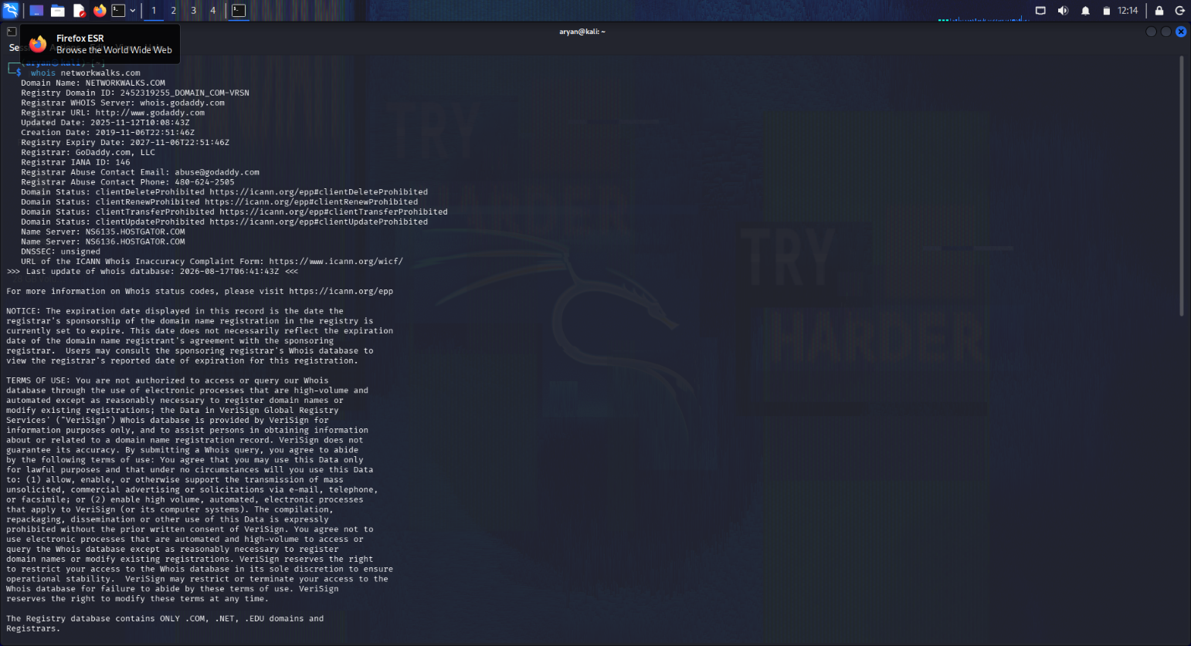
Figure 1 – Evidence extracted from the uploaded Week 2 report
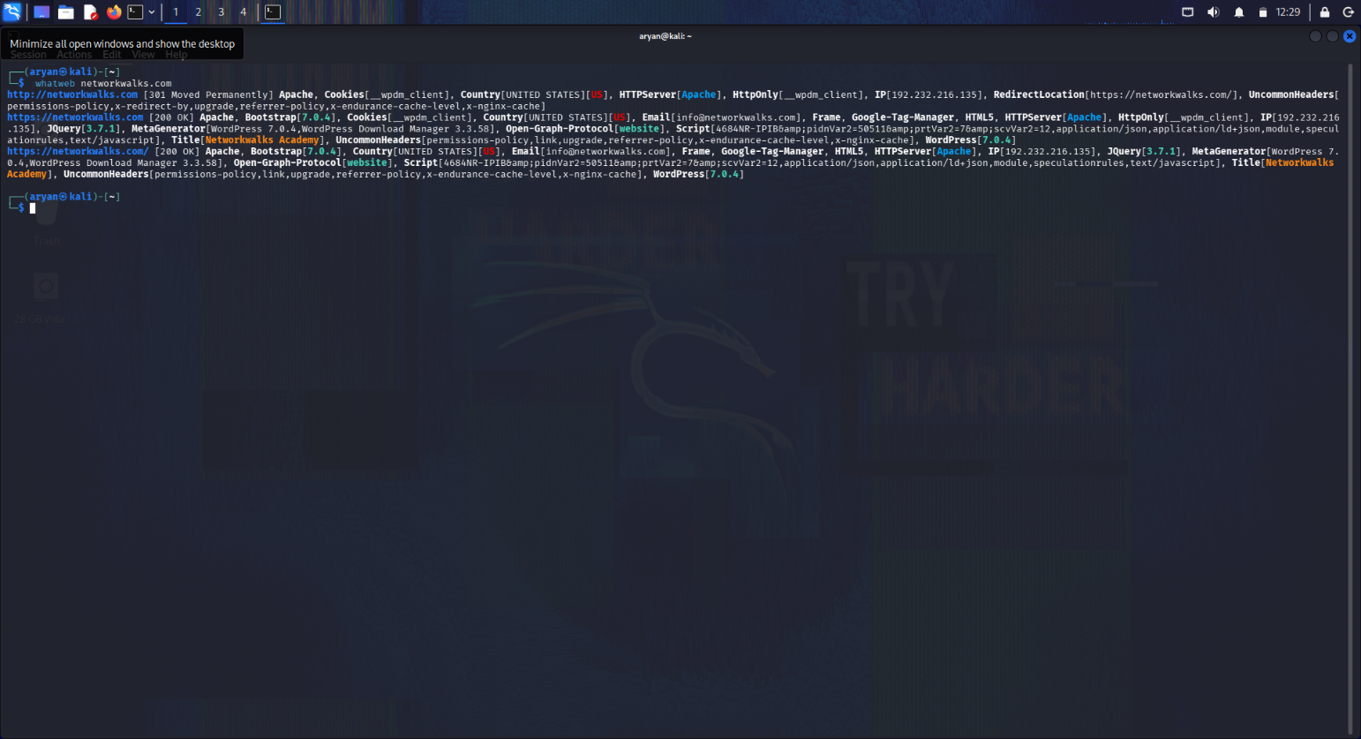
Figure 2 – Evidence extracted from the uploaded Week 2 report
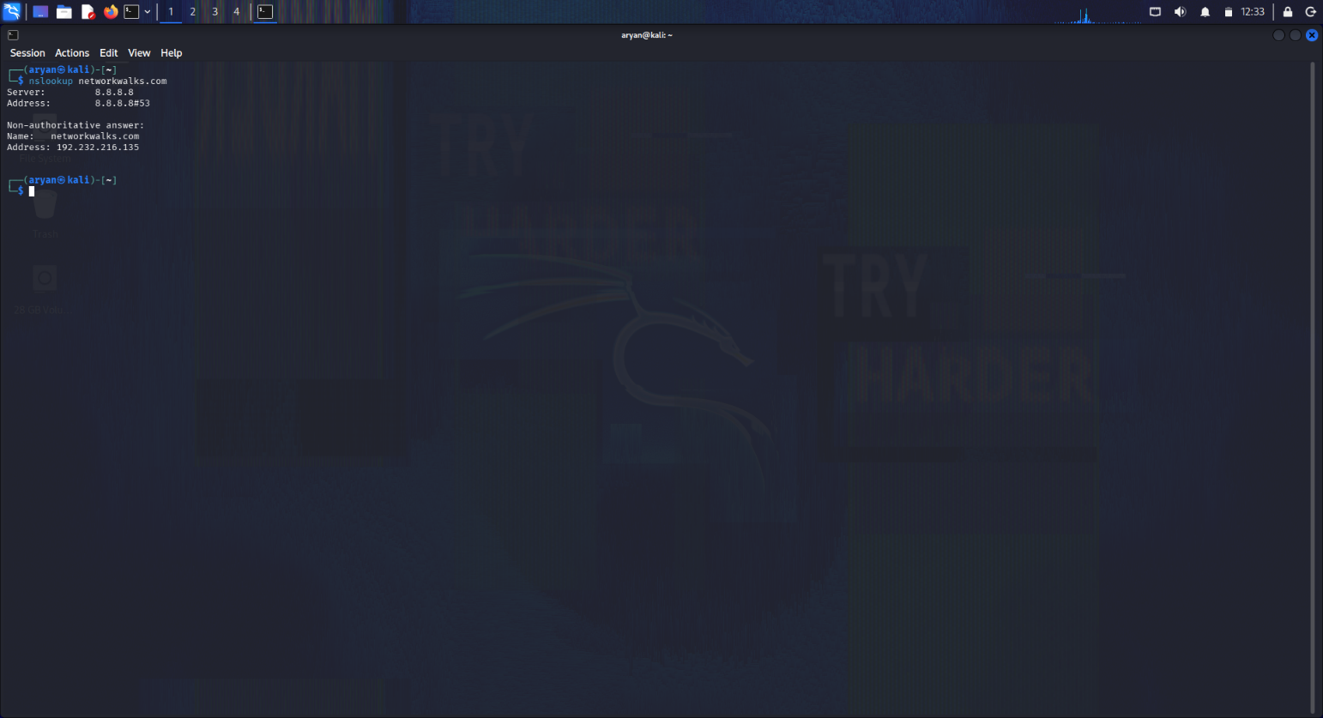
Figure 3 – Evidence extracted from the uploaded Week 2 report
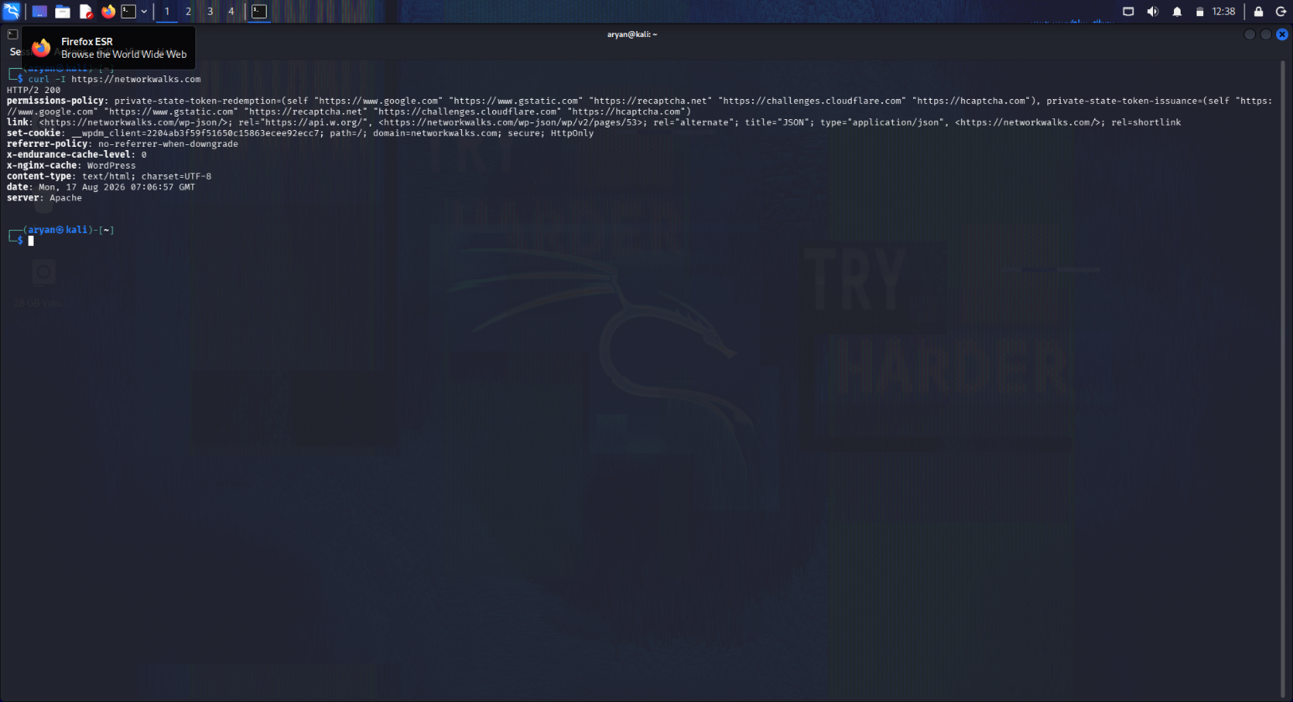
Figure 4 – Evidence extracted from the uploaded Week 2 report
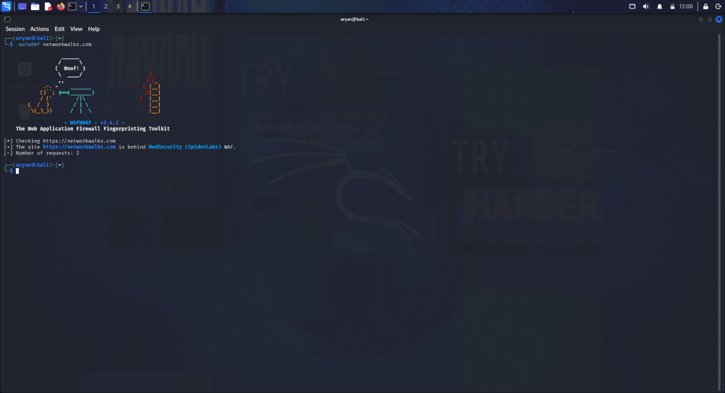
Figure 5 – Evidence extracted from the uploaded Week 2 report
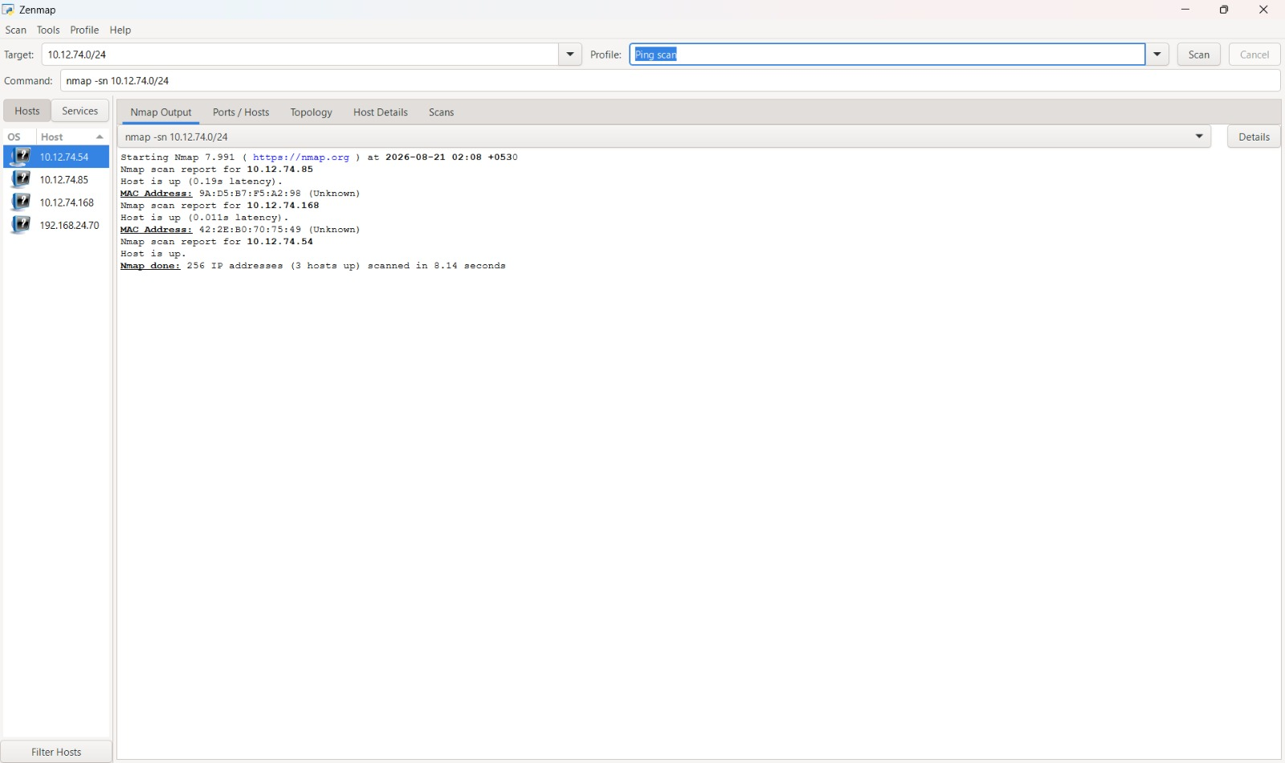
Figure 6 – Evidence extracted from the uploaded Week 2 report
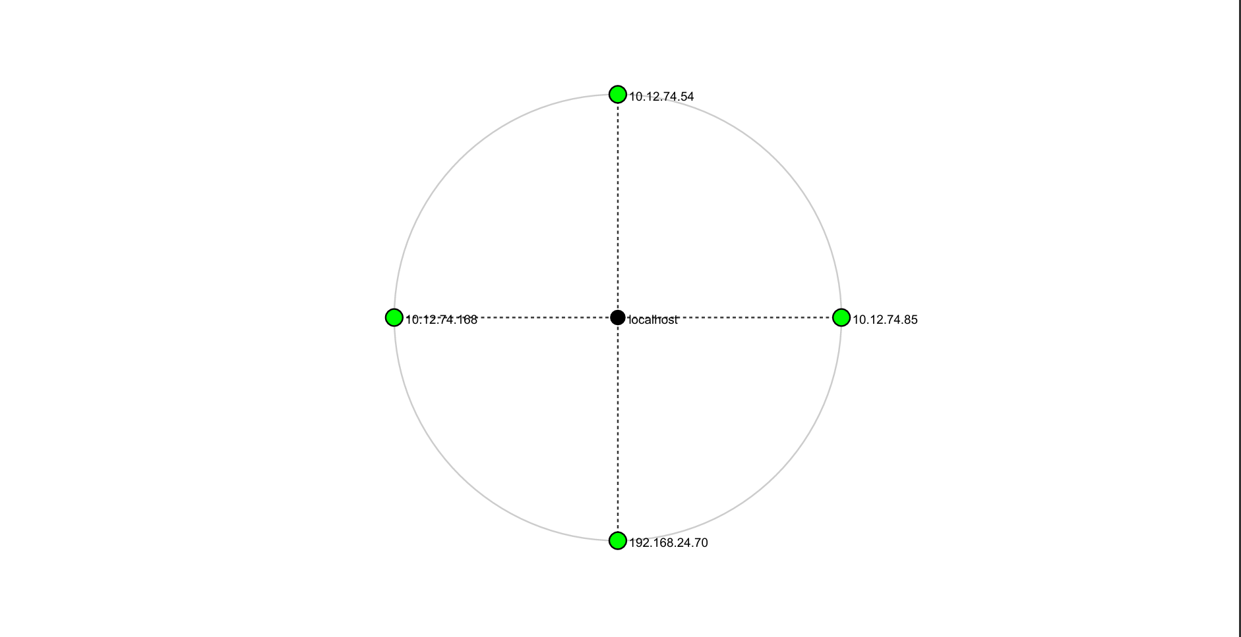
Figure 7 – Evidence extracted from the uploaded Week 2 report

10. Conclusion
During Week 2 of the Cybersecurity & Ethical Hacking internship, the practical activities covered footprinting, reconnaissance and network scanning. The footprinting phase demonstrated how multiple Kali Linux tools can be combined to collect domain, web-technology, HTTP, WAF and DNS information. The scanning phase demonstrated how Zenmap can be used to identify active hosts and visualize a local network.
The exercises reinforced the importance of information gathering before deeper security assessment. They also demonstrated the value of documenting commands, observations, evidence, potential impact and recommended controls in a structured security report.
Most importantly, the work emphasized authorized scope. Reconnaissance and scanning are legitimate security activities when performed with permission, but the same techniques can become unlawful when used against systems without authorization.

11. Learning Outcomes
- Understanding of passive and active reconnaissance concepts.
- Practical use of common Kali Linux reconnaissance utilities.
- Improved understanding of DNS and domain infrastructure.
- Basic web-technology fingerprinting using WhatWeb.
- Understanding of HTTP response headers and exposed endpoints.
- Identification of WAF technologies using Wafw00f.
- DNS record enumeration using DNSRecon.
- Local network discovery using Zenmap.
- Basic interpretation of IP, MAC and host-discovery information.
- Security reporting, risk interpretation and evidence documentation.

12. Project Information
Program | Cybersecurity Program at Networkwalks
Week | 02
Participant | Aryan Doshi
Focus | Footprinting, Reconnaissance & Network Scanning
Repository | GitHub – johnwick-2103

13. Author
Aryan Doshi
Cybersecurity Intern
GitHub: https://github.com/johnwick-2103
LinkedIn: https://www.linkedin.com/in/aryan-doshi-530500351

— End of Report —

